### Chapter 1

**Introduction**

* 1. **Introduction**

IoT based home automation system can be controlled over mobile devices. This system can perform varied functions to be performed at home. This allows accessibility over internet from any corner in the world. The main focus of this project is to minimize the usage of electricity and reduce human efforts. The Home Automation system (HAS) incorporates various aspects of technologies such as wireless networking, communication over cloud. The data to be analyzed is stored onto the cloud. The user can access multiple appliances over the internet as per their convenience. This is a low cost system. This system can control multiple devices.

## Motivation

IoT can be used to provide an ecosystem for individuals or organizations to get the most from the limited energy sources of energy by using the evolving technologies like data mining, ambient intelligence and Big data.

Collectively these technologies can be used to create a firmly secure and automated environment along with the specialized and optimized usage of energy, with an amplified approach toward the conservation of the most worn out energy of electricity.

Most of the IoT Development are focused on the Automation of the simple tasks and controlling them remotely whereas IoT would make a genuine difference using that network for real time tracking of the Systems and analyzing the sources to predict the further behavior and thus reacting to the current state, resulting the motive of optimal usage of energy.

## Problem Definition

Capture information from meters regarding electrical appliances, analyse it, apply deep learning techniques and share it with the users and allow them to perform appropriate functions & provide remote home security.

## Objectives of Project

The system focuses on automating the process of analyzing and conserving by sharing information to the users. The data will be available to the appropriate users.

The main objective of the system includes the following:

* + 1. The system will statistically analyze the previous data.
    2. The users will be able to control the appliances on their fingertips.
    3. Based on the analyzed data, the users will be offered appropriate operations.
    4. The system will fuzzily adapt the previous data and perform operations agreeable to the users.

## Scope of the project

The system will provide a platform to the user to analyze the electricity usage of the specific user and generate the statistically estimated consumption and use the collected data to predict the usage with reference to the changing seasons of the year. The process is automated and optimized for cost-efficiency by providing user friendly interface.

## Application of project

IoT based energy usage analysis using deep learning techniques will provide the predictive approach of the user’s energy usage thus using the IoT device for energy estimation where most of the research is done on the Automation purposes. The product will also provide the normalized consumption weightage of Different

appliances at the resident. This could be further extended to make a security system and alert alarm systems for the deployable places like flats, bungalows or commercial offices.

## Projects Impact Analysis

This project will majorly attract the population of the conservative mindset with proper use of technology to lover the exhaustion of the non-renewable energy sources as the major source of electricity generation in India is by Coal. As most of the Automation projects lack the energy saver feature this could assist them and increase their efficiency to a greater extent.

## Expected Outcome

The end product will have the ability to analyze the electricity usage of the specific user and generate the statistically estimated consumption and use the collected data to predict the usage with reference to the changing seasons of the year. It will use various energy saving techniques to conserve more energy developing the required results.

## Organization of the Project report

The organization of the Project Report is as follows:

Chapter 1: It consists of the introduction to the project. The problem definition of the project is explained. Also the motivation for the project, scope, objectives, outcomes, impacts of the project has been discussed.

Chapter 2: This chapter mainly focuses on the literature review and the proposed work of the project

Chapter 3: This chapter deals with the initial stages of the project such as requirement gathering, planning and analysis.

Chapter 4: This chapter focuses on he design part of the project. It consists of the Data Flow Diagrams (DFD), UML Diagrams such Use case diagrams, Flowcharts etc.

Chapter 5: This consists of the conclusion of the project.

### Chapter 2

**Proposed Work and Literature Review**

* 1. **Literature Survey**

The existing approach for energy management is either a manual process, wherein people have to manually take efforts to conserve energy, or a platform based energy management software which is completely dependent on the user’s concern.

The problems with the existing system are:

* + 1. The existing system involves complete human interaction.
    2. Most of the automation projects lack the energy saving feature.
    3. Most automation system lacks the security feature.
    4. Very few existing systems provides a simple to use UI.

### Market Survey

1. A proper market research or survey is necessary before developing any project. We need to analyse the need of the clients for our project also the demand in the market. Everything depends on demand and supply policy. If the demand is more and use of our product will be more. We need to analyse how our system is better compared to other systems this can be done by identifying gaps and also providing features that our others are not providing and make our product more useful.
2. This project will majorly attract the population of the conservative mindset with proper use of technology to lover the exhaustion of the non-renewable energy sources as the major source of electricity generation in India is by Coal.
3. As most of the Automation projects lack the energy saver feature this could assist them and increase their efficiency to a greater extent.

### Society Survey

1. Any development is directly or indirectly related to society. It may either affect the society in a positive way or a negative way. If the development is not acceptable to the society then there is not much scope of it being accepted in the world or at larger scale.
2. Thus, a survey must be carried out before hand of what they feel of this development and take their considerations into account before starting the project development.
3. Hence, we too asked people in our neighborhood about our project whether they would like to use a system which will help them to exhibit their products and services to the end users and users will get notifications of the same and the response was positive.
4. In today’s world, where majority of people use mobile applications for their day to day needs, the application for advance marketing will be a success.

## Proposed Work

The application overcomes the problems in the current system in the following way:

* + 1. The proposed model will provide the predictive approach of the user’s energy usage thus using the IoT device for analysis.
    2. The product will also provide the normalized consumption weightage of different appliances at the user’s place.
    3. Users can set predefined operations to be performed. For example, switch on the air- conditioner before reaching home remotely from the mobile app.
    4. This system will also include a security camera mounted outside the door and the video footage of past 7 days will be stored.
    5. This camera will also have a face detection algorithm running in the application so as to inform the user by a sms or by mail. The app will also be able to learn and recognize the faces.

### Chapter 3

**Requirement Gathering, Analysis and Planning**

* 1. **Requirement Specification**

**3.1.1 Functional Requirements**

* + 1. The system will require to install hardware boards and connect the appliances to the board via the ESP 8266 Wi-Fi module.
    2. The security camera module will require to send text messages to the user and even an e-mail.
    3. The database will store all the credentials of the user.
    4. The energy consumption statistics will also be stored in the database and a report document can be generated of the same through the application.
    5. The whole system will be using an Internet connection since usage of IoT devices are involved.
    6. The user will be able to access the home appliances remotely through the application.
    7. The user can set an event to be triggered at a particular time.
    8. The system will generate a log file, so as to be useful for further optimization of the system.
    9. The system will require to train the prediction model on a cloud platform since it involves a lot of computation power.
    10. The application will require to access the storage of device to learn and train the security camera for facial recognition.

### Non-functional Requirements

* + - 1. **Performance Requirements**

Below are some of the performance requirements:

* + - * 1. The security camera video feed of the last 7 days can only be stored.
        2. The system will require to use an active internet connection to function.
        3. The system will require an efficient database as many data will be stored for prediction analysis.
        4. The android application will require an OS 5.0 or above.

### Security requirements

1. The system will store credentials of the user with encryptions and salt crypts and thus ensuring no hindrance with the data.
2. The security camera video feed will be stored on the device instead of the database ensuring no alteration.

### Software Quality Attributes

* + - * 1. The system has an application that is very easy to learn and user friendly.
        2. The application has a module for prediction analysis which uses deep learning convolutional model to predict the data.
        3. The application is reliable and secured and every sensitive information of user stored is encrypted.
        4. The application will generate a weekly log file and will be sent to developers so as to optimize the system.
        5. The application will also allow user to generate a report of the data collected with some statistics.

### Supportability

1. The system’s hardware will generate the data and it will be processed by the application.
2. The application is developed on both the web and mobile platform.

## Feasibility Study

### Technical Feasibility

1. The Technical Feasibility Study assesses the details of how will you deliver a product or service (i.e., materials, labor, transportation, where the business will be located, the technology needed, etc.). It is a very effective tool for long term planning and trouble shooting.
2. We are going to develop the system by gathering client requirements and provide them all the features. IoT based energy usage analysis using deep learning

techniques will provide the predictive approach of the user’s energy usage thus using the IoT device for energy estimation where most of the research is done on the Automation purposes.

1. The product will also provide the normalized consumption weightage of Different appliances at the resident. This could be further extended to make a security system and alert alarm systems for the deployable places like flats, bungalows or commercial offices.

### Financial Feasibility

1. A financial feasibility study projects how much start-up capital is needed, sources of capital, returns on investment, and other financial considerations. It looks at how much cash is needed, where it will come from, and how it will be spent.
2. Since we are the developers, the cost will always be within the financial feasibility range.
3. We will mostly be needing finance for maintaining servers and for integrating required API for proper implementation of application.

## Methodology

1. In this project, we as a team have decided to proceed with SDLC model. The reason to choose this specific model is due to its stable system requirements and measurable progress of system.
2. SDLC model will follow a linear trail where once decision is made and finalized pathway will not be changed. The linear structure of waterfall model is very favorable for our condition where client-interference will be at minimum and final assessment followed by presentation will be conducted at the end.

## Technology

There are myriads of technology used in this project. There are both hardware parts and software parts in the project.

### Hardware

The hardware part uses the raspberry pi as a CPU and uses it control and manage the data on its side. There is a Voltage regulator which controls the current flowing through it using the resistance. There is an ESP-8266 wi-fi module which transfers the data from various target devices to the pi. The same pi uploads the data on the cloud. At this point the hardware job is done.

### Software

The software part includes the platform on which the product will run on. They run on both web and android application. To develop it as an Android Application, Java is needed. The web app uses python to run on the backend and html/CSS/JavaScript on the front end. For the communication between backend and frontend a python library “Flask” is used. For the training of the prediction model a cloud platform is used to train it since it requires high gpu powers. The cloud is simple INODB engine database which can connect through the web app as well as to the android application too.

## Gantt Chart and Process Model and Client Communication

|  |  |  |  |
| --- | --- | --- | --- |
| Sr. No. | Activity | Plan Date | Complete Date |
| 1 | Project title selection | 03/07/2017 | 07/07/2017 |
| 2 | Project Proposal | 06/07/2017 | 10/07/2017 |
| 3 | Study of exiting products | 11/07/2017 | 10/07/2017 |
| 4 | Study of ongoing projects in same direction | 10/07/2017 | 26/07/2017 |
| 5 | Resource identification and Data collection | 26/07/2017 | 12/08/2017 |
| 6 | Identification of security approach | 13/08/2017 | 28/08/2017 |
| 7 | Selection of energy tracking mechanism | 28/08/2017 | 15/09/2017 |
| 8 | Selection of hardware components | 13/09/2017 | 24/09/2017 |
| 9 | Purchasing | 25/09/2017 | 30/09/2017 |
| 10 | Configuration of platform | 01/10/2017 | 05/10/2017 |
| 11 | Constructing hardware | 06/10/2017 | 03/12/2017 |
| 12 | Developing software | 20/11/2017 | 31/01/2018 |
| 13 | Testing model | 11/01/2018 | 12/02/2018 |
| 14 | Review and bug fixes | 11/02/2018 | 26/02/2018 |
| 15 | Final testing | 23/02/2018 | 07/03/2018 |
| 16 | Result Analysis | 03/03/2018 | 13/03/2018 |
| 17 | Recommendations | 14/03/2018 | 21/03/2018 |

Table I

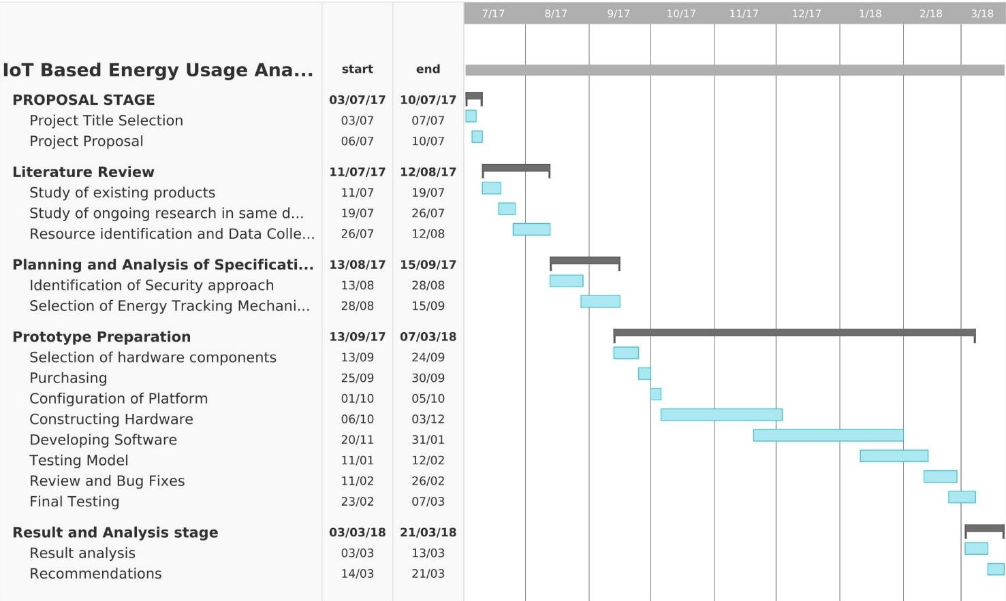

Figure 1

## Process Model

In this project, we as a team have decided to proceed with SDLC model. The reason to choose this specific model is due to its stable system requirements and measurable progress of system.

SDLC model will follow a linear trail where once decision is made and finalized pathway will not be changed. The linear structure of waterfall model is very favorable for our condition where client-interference will be at minimum and final assessment followed by presentation will be conducted at the end.

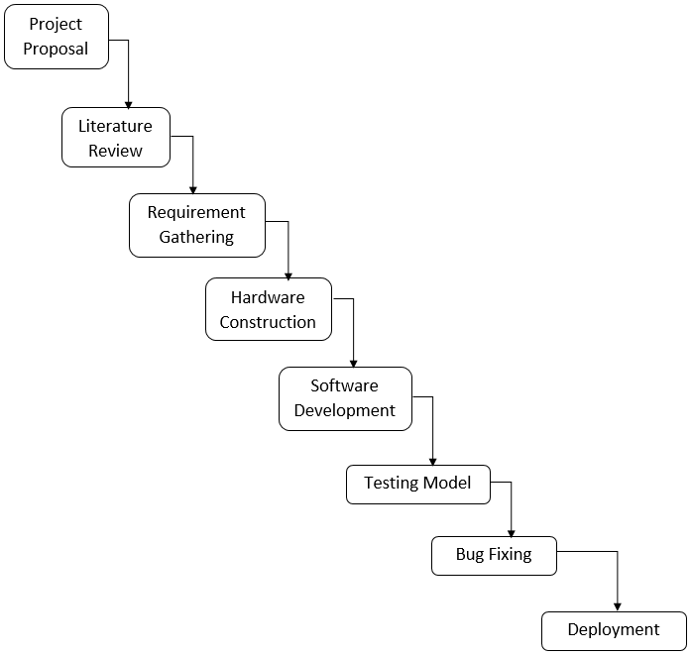

Figure 2

## Client Communication

### Clients Identified:

1. **Non-Working & Working Client**
2. **Differently-abled & Senior citizens Client 1 (Non-Working & Working Client):**
3. How do you remain aware about the total energy consumed by your appliances? Ans. We get to know about the units by the monthly electricity bill.
4. Do you think the evaluation of monthly energy consumption would help you? Ans. Yes. To regulate the energy consumption in future.
5. How do you remain aware about the efficiency of your appliances?

Ans. By its performance over the years, but there is no such accurate unit of measurement for efficiency. So the measure of efficiency may differ from user to user.

1. Do you think comparison against your previous utilization data help you prepare your budget?

Ans. Definitely yes. This would be of major help to any individual as it would help resolve the economic consequences.

1. How do manage your appliances when you are away from your place?

Ans. There is no such available technology to manage the appliances while being away from it, unless the home has an automated system installed.

1. How do you have control over the usage of appliances by your kids?

Ans. By personally controlling the appliances manually, which is not possible all the time.

1. How do you manage your appliances during the different seasons of the year?

Ans. By manually regulating the appliances whichever required as per the season. For e.g. In winter we rarely switch on the air conditioner whereas in summer its usage is high.

1. Some appliances consume more energy, which may lead to short circuit. Will identification of those appliances prove to be helpful?

Ans. This would prove to be quite helpful as this would avoid a disastrous events such as short circuit, thereby safeguarding ourselves as well as the different appliances in use.

### Client 2: Differently-abled & Senior citizens

1. How do you manage the appliances at your home?

Ans. Being physically disabled, it’s quite difficult to regulate the appliances manually. So it becomes quite necessary to always have someone present with me.

1. How do you come to know who has arrived at your doorstep? Do you feel safe to open to door without having prior when you are alone at home?

Ans. Being alone at home, it’s quite risky to directly open the door because there have been several cases where some people purposely target senior citizens and handicapped.

1. How is conservation of energy is important?

Ans. As nowadays technology has taken a huge hike so is the wastage of the energy instead of knowing the fact that their distinction is inevitable, as they don’t know the importance of living with these comforts.

## System Analysis (functional model, structural model and behavioral model)

### Functional Model

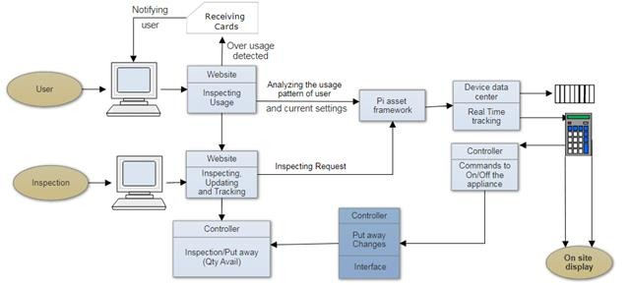

Figure 3

### Structural Model

* + - 1. **Class Diagram**

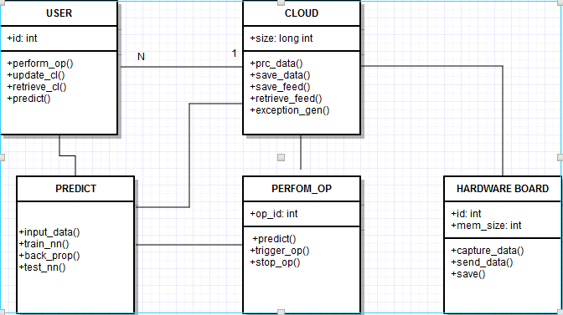

Figure 4

### Object Diagram

Figure 5

### Deployment Diagram

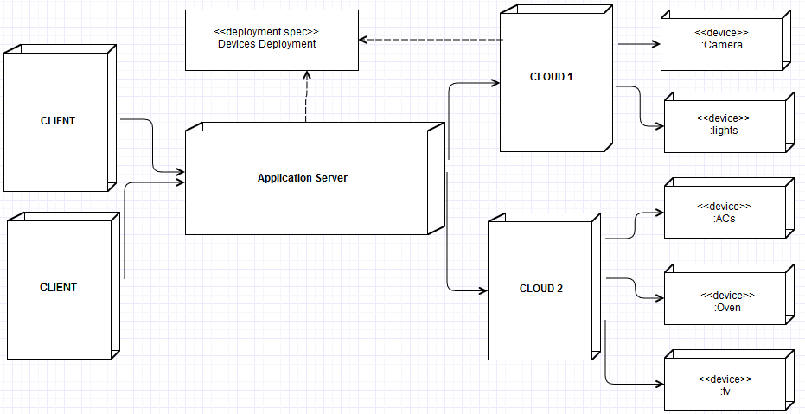

Figure 6

### Component Diagram

Figure 7

### Behavioral Model

* + - 1. **Use Case Diagram**

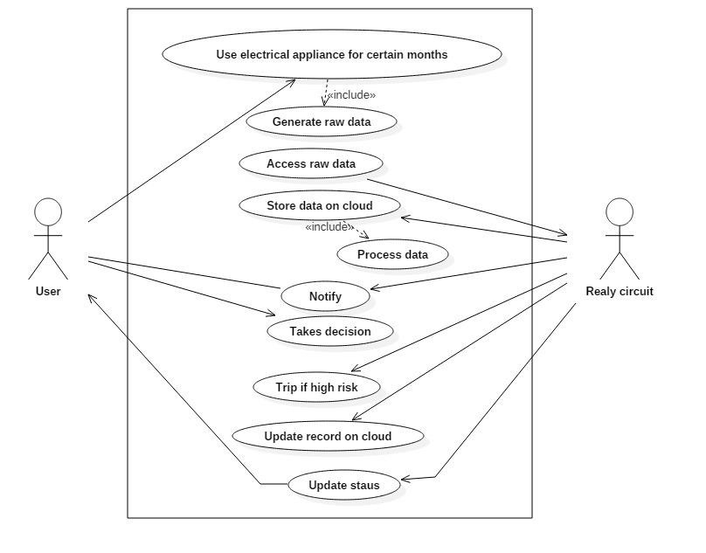

Figure 8

### Sequence Diagram

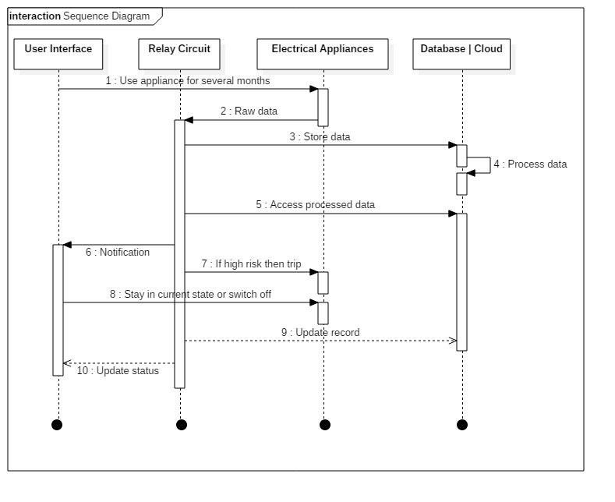

Figure 9

### State Diagram

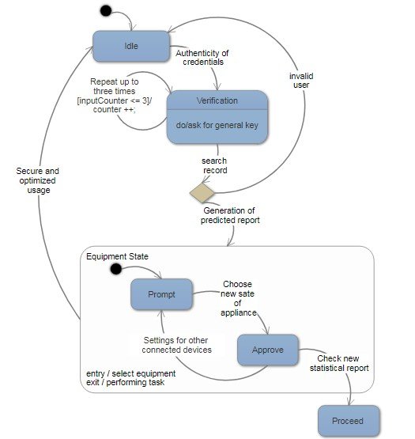

Figure 10

### Chapter 4

**Design phase**

* 1. **Block Diagram / Architecture**

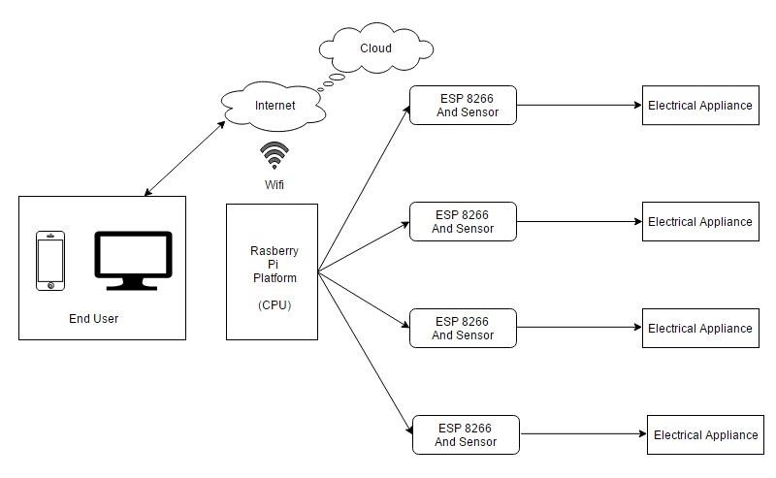

Figure 11

## Algorithm/Flowchart/Pseudo Code Design

### Machine Learning Prediction Model Linear Regression Algorithm. (Using Supervised Learning)

* + 1. Input excel sheet data to the model.
    2. Divide the data into training data and testing/validation data.
    3. Create an instance and feed the inputs to the input layer.
    4. Assign random weights to input layer and pass it to hidden layer 1.
    5. Create an instance of regression fit line Y = a*x + b
    6. Hidden layers produce some values which are normalised using sigmoid activation function.
    7. Output is compared to desired output and error is calculated.
    8. Error is back propagated to the hidden layer 1 and weights are adjusted
    9. Biases are used to prevent decision from outside the scope of training data.
    10. Steps 6 to 9 are repeated until desired output is produced.

### Machine Learning Prediction Model Linear Regression Pseudo Code. (Using Supervised Learning)

1. #import essentials
2. #import Pandas, numpy, keras..
3. from sklearn import linear_model
4. #load train and test datasets
5. #identify feature/response neuron
6. x_train = input_variables_values_training_datasets
7. y_train = target_variables_values_training_datasets
8. x_test = input_variables_values_test_datasets
9. linear = linear_model.LinearRegression()
10. linear.fit (x_train, y_train)
11. linear.score(x_train, y_train)
12. print(linear_coef) & print(linear_intercept)
13. predicted = linear.predict(x_test)

## User Interface Design (Snapshots)

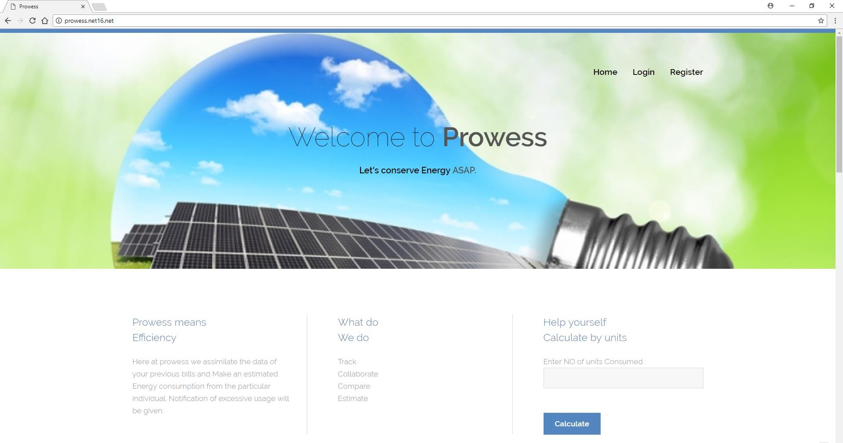

Figure 12

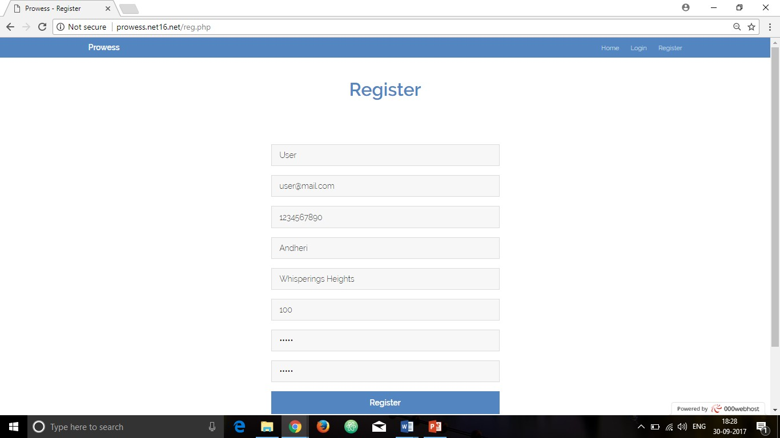

Figure 13

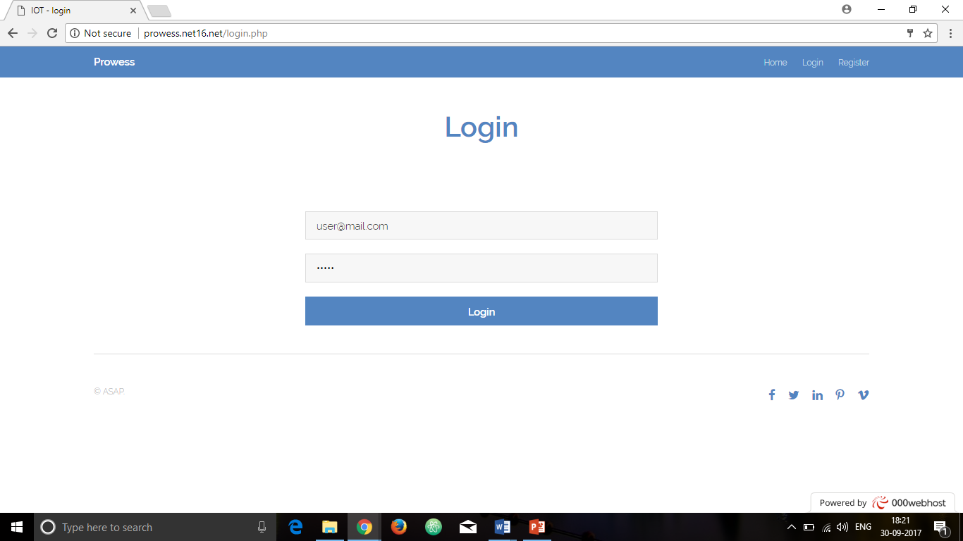

Figure 14

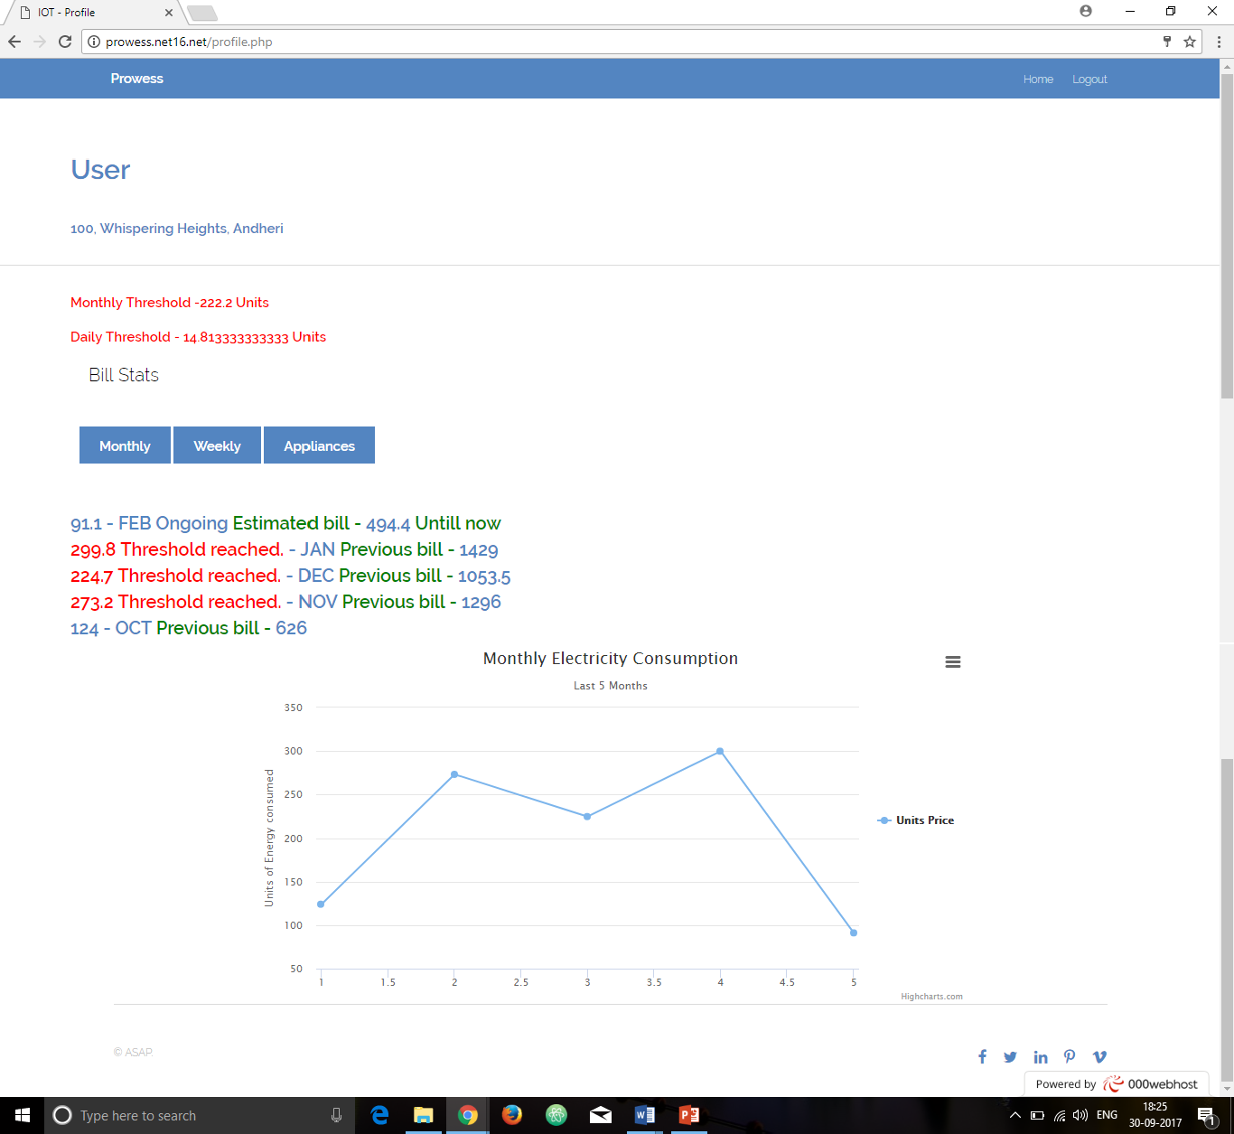

Figure 15

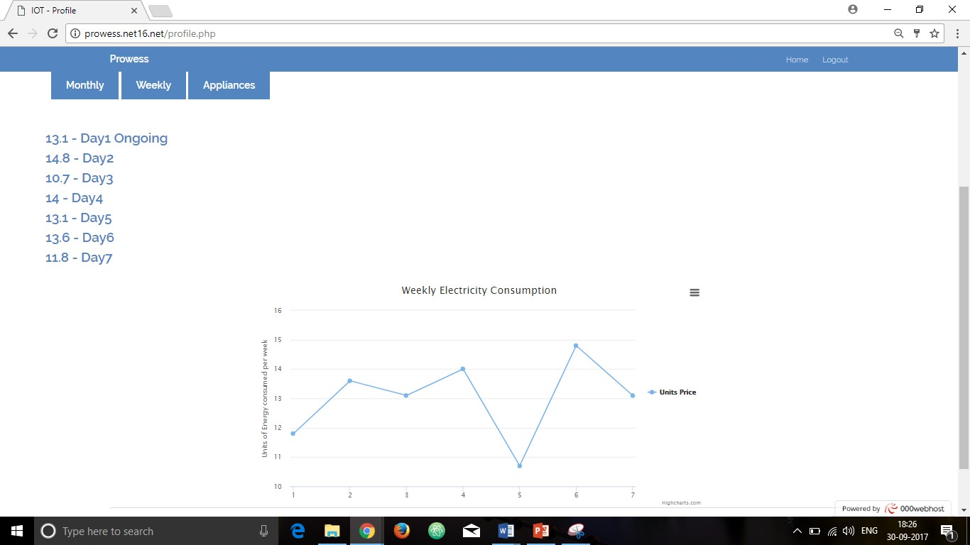

Figure 16

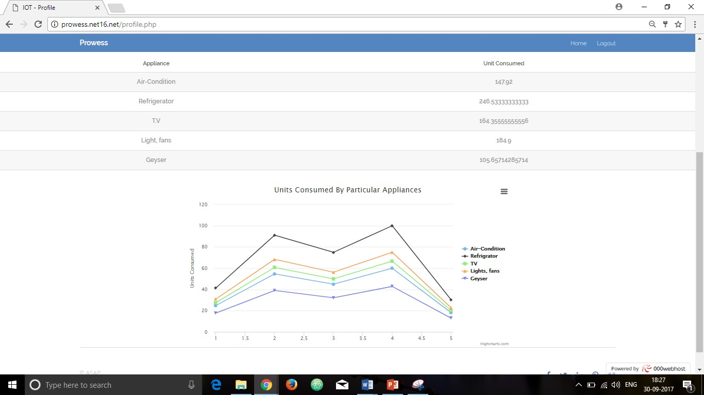

Figure 17

## Database Design/ Data structure

The database used in the InnoDB Engine which is an open source database. It is of high performance and reliability. It is a default MYSQL storage engine. The data structure used for this database is B-tree index, Full-text Search indexes and index caches. The database also supports cluster searching.

### Database for storing energy units consumed in the previous months and the past week:

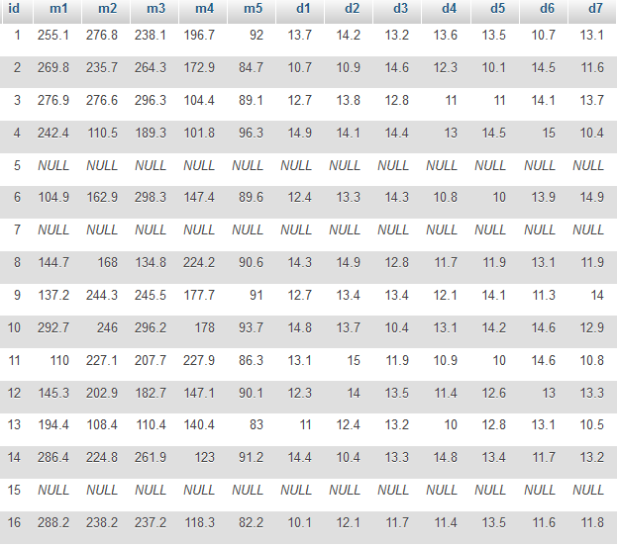

Figure 18

### Chapter 5

**Conclusions**

The end product will have the ability to analyze the electricity usage of the specific user and generate the statistically estimated consumption and use the collected data to predict the usage with reference to the changing seasons of the year. It will use various energy saving techniques to conserve more energy developing the required results.

# References

1. Ravi Kishore Kodali, Vishal Jain, Suvadeep Bose and Lakshmi Boppana, “IoT Based Smart Security and Home Automation System”,[Computing, Communication and Automation (ICCCA), 2016 International Conference on](http://ieeexplore.ieee.org/xpl/mostRecentIssue.jsp?punumber=7795276) pp. 1286 – 1289, April 2016.
2. VinaySagar K and Kusuma S, “Home Automation Using Internet of Things”, International Research Journal of Engineering and Technology, Volume 2, Issue 3 on pp. 1965 – 1970, June 2015.
3. Stefan Matlak, RazvanBogdan, “Reducing Energy Consumption in Home Automation based on STM32F407 Microcontroller”, IEEE, November 2016.
4. Su ZinZin Win, Zaw Min MinHtun, HlaMyoTun, “Smart Security System for Home Appliances Control Based On Internet Of Things” IJSTR, Volume-5, Issue 6, June 2016.

## Proposed Conference Paper

**IoT Based Energy Usage Analysis Using Deep Learning Techniques**

Ashokkumar Sharma Computer Engineering Dept.

Thakur College of Engineering & Technology Mumbai, India

[ashurocks1996@gmail.com](mailto:ashurocks1996@gmail.com)

Shivam Shukla Computer Engineering Dept.

Thakur College of Engineering & Technology

Mumbai, India [freaky.shivam97@gmail.com](mailto:freaky.shivam97@gmail.com)

Agrim Singh Computer Engineering Dept.

Thakur College of Engineering &

Technology Mumbai, India

[agrimsingh10@gmail.com](mailto:agrimsingh10@gmail.com)

Anand Khandare Assistant Professor,

Computer Engineering Dept.

Thakur College of Engineering & Technology, Mumbai, India

[anand.khandare1983@gmail.com](mailto:anand.khandare1983@gmail.com)

### ABSTRACT

Smart Homes will control all the appliances through handy platforms like web apps and android application. This system will take control of all the functions to be performed. Accessibility can be expanded by

regulating the appliances from anywhere thereby reducing human efforts to a minimum level. The Home Automation System (HAS) incorporates various aspects of technologies such as Wireless Networking, Communication over cloud. Data collected from the IoT devices provide

a real time access over multiple appliances via Internet.

### Keywords

Home Automation System (HAS), Internet of Things (IoT), Raspberry Pi, Security Control, Wireless Networking, Automation Technology.

### INTRODUCTION

IoT is one of fastest growing technology. With developing technology demand for internet is also increased tremendously.

There have been great advancements in Automation Technology. IoT is

internetworking between two or more devices with less or no human intervention. IoT analyzes the data retrieved from the sensors and performs appropriate activities thereby saving human time. With the rapid increase in the number of users of internet, it has made Internet a part of life, and IoT is the latest and emerging internet technology. The assurance to people about their home activities and securities led to the advancement of Home Automation System. One can easily track the activities at her/his home even in the event of absence. The system will continuously update the system information as well as the user.

### ARCHITECTURE OF THE SYSTEM

Fig.1: Architectural model

### HARDWARE IMPLEMENTED

**3.1 ESP8266**

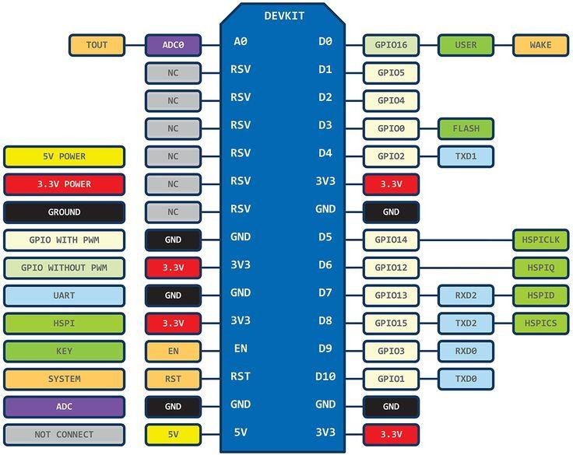

Fig.2: ESP Module

The ESP module is an integrated chip with an inbuilt strong and high range Wi-Fi connectivity. This module provides most efficient quality of services to the system developed, by transferring the data wirelessly to the database over the cloud and making the networks operational availing the remote access features.

### Wi-Fi Module

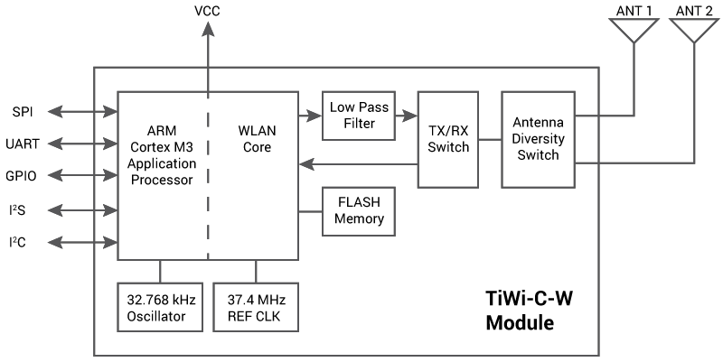

Fig.3: Wi-Fi Module

Wi-Fi stands for Wireless Fidelity. Using Wi-Fi is very convenient and easy-to-use than a microcontroller. A Wi-Fi enabled environment allows to send or receive data to the host network wirelessly. Using Wi-Fi is a quick and less hectic way of transmitting data. This project requires loads of data to be transferred over the cloud using Wi-Fi modules which is operated by the server. The range of Wi-Fi modules is very high compared to Bluetooth and it can also penetrate through objects. Hence can be placed anywhere in the house and would cover every corner in range. The use of this module in the project will be for transferring the data obtained by the hardware which sends it to the server and stored into the buffer memory which then is transferred to cloud over Wi-Fi and the operations can be performed on the data.

Wi-Fi module will provide a real time interaction between the user controlling the appliances and the appliances through the available platforms.

### Raspberry Pi

The Raspberry Pi is a single board processing unit of very small size. The Raspberry Pi is the core processing unit, because of its small-size and high usability.

It has low power consumption and wide use because of its low cost.

The GPIO pin configuration is as shown below-

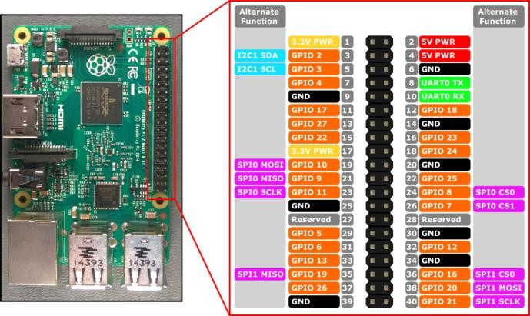

Fig.4: GPIO pin configuration

### Voltage Regulator

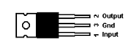

Fig.5: Voltage Regulator

### Connecting the Home Automation

**Circuit**

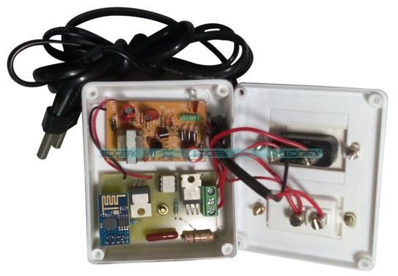

Fig.7: Home Automation using IOT Project Circuit

The home automation using IOT project circuit can be connected using various

Voltage regulator is a device which lets the current flow in a regulated way. There are types of voltage regulators such a fixed voltage regulator and variable voltage regulator.

The fixed regulator is configured to allow only a particular amount of current while the variable regulator has a range of current which can be passed. Here, in this project a variable voltage regulator is used so that is automatically adjusts itself and configure to let pass the required amount of current and the amount is recorded by a meter and it is stored in the cloud using the Wi-Fi module. This recorded data will be used to provide the fluctuations in the voltage and keep a track on the over usage of power.

electrical and electronic components, modules, blocks & connecting wires as shown in the above figure.

### WORKING OF PROTOTYPE

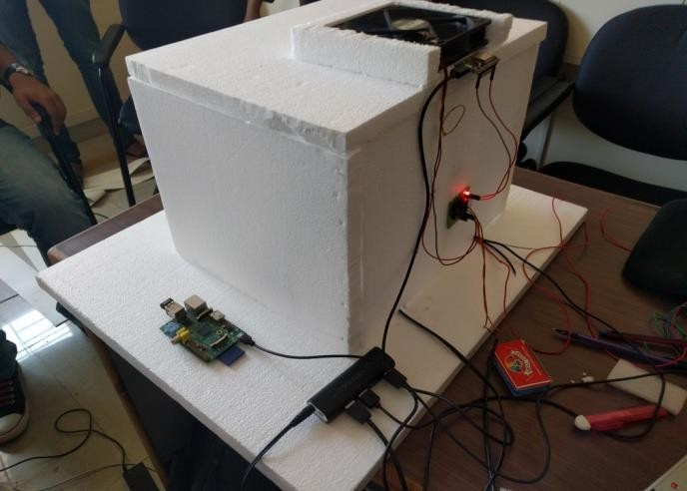

Fig.8(a): Prototype

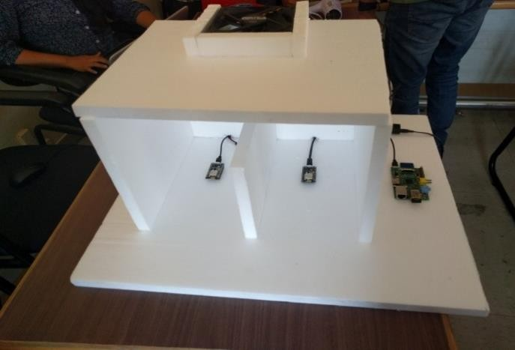

Fig.8(b): Prototype

All the information will be transmitted over the cloud to the user. Whenever any unusual activity is noticed the user will be notified by the system. The Raspberry Pi is used are the core processing unit, because of it’s small-size and high usability. The load can be controlled and monitored using a web page or android app with user configurable front end. The user can send commands through the allotted IP and these commands are fed to Wi-Fi module. The Wi-Fi module is configured to access internet using any nearby wireless modem. The commands received by a Wi-Fi module are executed by a program within a Wi-Fi module. The Wi-Fi module interfaced through the loads are turned ON & OFF based on commands. The load status (ON or OFF) will be displayed on the web page and app.

### Energy Regulation System

The electricity instead of directly passing to the appliance, is passed through the voltage regulator. The voltage regulator maintains the flow of current and avoids overloading. The controlled flow of current is then passed through a voltage-meter which records the units of voltage used. This data is sent to raspberry pi server and the server stores the data in the database. This data is captured weekly as well as monthly. These statistics are used to calculate the energy consumption bill. An algorithm is used to calculate the energy bill weekly and monthly. The user can set a limit for the units of energy consumed. If the threshold for the unit is reached the user will be notified. The user can switch on/off using as well as regulate the flow of voltage to particular appliances. For example, user can dim the lights, regulate the fan, etc.

### Security Control System

The user can control every appliance from the application. In case the user isn’t at home, she/he can remotely power off the active appliances. This system can be used for security at doors. A CCTV is mounted in front of door. If someone rings the bell and no one is at home, depending on user’s choice a picture from the CCTV or a live video feed can be sent to the user via the

application or display it on our web app. This control comes handy in situations like

– when no one is at home and the child comes back from school and rings the bell. The user will be notified and the digital door can be opened remotely by the user. The door opening mechanism is based on a digital lock which compares a piece of

This web app serves as a platform between the user and the electrical appliances under monitor. This portal displays all the statistics about the energy consumed by appliances.

The user has access over the monthly as well as weekly energy consumption. This portal displays statistics about last five months and the previous seven days. It also tracks the energy consumed by each and every appliance installed at home. In order to attract to reduce user’s efforts the portal provides a graphical representation

encrypted code sent by the user. This also ensures that even when the cloud or the database is compromised the security code is visible or understandable by the hacker. Also the code from the client (user) side is double encrypted so that it cannot be tapped by a middle man.

1. **SOFTWARE DEVELOPMENT** of the statistics. All this data is retrieved from the database stored on the cloud.

The system based on the previous energy consumption dynamically sets a threshold for every month. If the monthly usage crosses the threshold value, the user is notified. This not only works for the entire house, but also works for each and every appliance. As a control measure the user can switch the appliances on or off by clicking the ON/OFF button available on the portal.

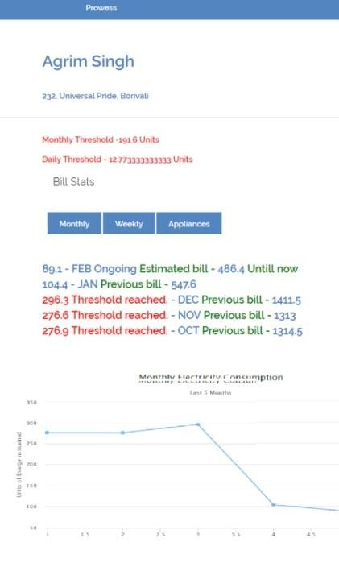 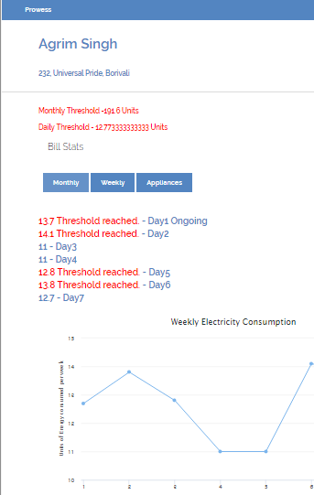 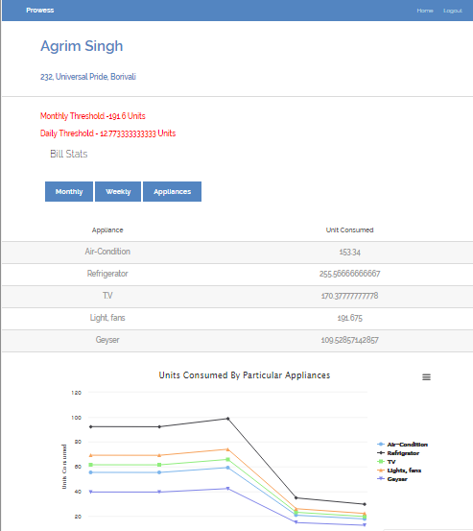

Fig.9(a): Monthly Analysis

Fig.9(b): Weekly Analysis

Fig.9(c): Monthly Analysis

### FURTHER SCOPE

Using this system as framework, the system can be expanded to include various other options which could include home security feature like capturing the photo of a person knocking at the door

### ADVANTAGES

* 1. **User friendly**

The basic advantage is the easiness with which user can use this system. It serves the purpose of user convenience. Any user can learn and implement such heavy tasks within seconds. It becomes very easy to perform all the activities on your

then notifying to the owner and storing it onto the cloud. This will reduce the data wastage by the CCTV cameras used for doors records everything happening outside.

fingertips. Even if you are not present at home you can access all your home systems remotely. One can keep track of all the activities taking place in her/his home in their absence.

* 1. **Energy monitoring and saving** One can easily monitor the consumption of energy of their home appliances and save energy accordingly. The system will monitor unit consumption reading of all the appliances and generate a monthly as well as weekly statistics. It will also calculate individual appliances threshold reading. For Example, if a certain appliance at your home consumes more energy than the threshold you can get it repaired or replace it. In short, your smart product helps you to manage your home's energy consumption. Some "smart" devices can be synced up to your appliances with real-time energy information. This helps your home appliances know the most cost-effective voltage operate.

The system can be expanded for energy monitoring, and temperature moderation. This kind of a system with respective changes can be implemented in the hospitals for disable people or in industries where human invasion is impossible or dangerous.

### Security features

Security is one of major advantage of Home Automation System. Even during one’s absence, security is quite important.

With the help of security cameras we can easily eliminate unwanted people from our home. We can keep track of all the activities which take place at our place in our absence. We can keep a record of known people in our database. If the person on door is unknown the user will be notified i.e. an alert will be sent to user for every entry and exit that occurs in her/his home. There are many security benefits of HAS. User can keep track of all the events of her/his home even in their absence. There are different ways to send alerts to user i.e. via SMS or via email in case of unusual movements within their home premises. The main advantage is user can be relived and stress free because of HAS.

### Environment and Economical Contribution

When you choose HAS you choose to help to achieve the target of sustainable environment. You are directly contributing to environment by saving energy. With home automation system user uses energy in an efficient way which directly reflects in their electric bill. When you properly manage your energy, you can reduce your energy consumption, which may help you save

money. Basic advantage is money is saved.

### Parental Lock

Using home automation system parents can have total control on their kid’s activities. For example, one can set a timer on their TV set and after that if anyone tries to switch on the TV the user will be notified.

### Benefit to Disabled

People suffering from any physical disabilities can be benefitted by HAS. The usability can be expanded for the less abled users providing control to the appliances by using text to speech and speech to text making the application perform the task by actually interacting with the user. For example, a person on wheelchair can access all the electronic equipments easily on his fingertips.

### Entertainment

One can easily access all the mediums of entertainment using this system. For example, one can easily customize the music player and make changes accordingly.

### REFERENCES

1. Ravi Kishore Kodali, Vishal Jain, Suvadeep Bose and Lakshmi Boppana, “IoT Based Smart Security and Home Automation System”, [Computing, Communication and Automation (ICCCA), 2016 International Conference on](http://ieeexplore.ieee.org/xpl/mostRecentIssue.jsp?punumber=7795276) pp. 1286

– 1289, April 2016.

1. VinaySagar K and Kusuma S, “Home Automation Using Internet of Things”, International Research Journal of Engineering and Technology, Volume 2, Issue 3 on pp. 1965 – 1970, June 2015.
2. Stefan Matlak, RazvanBogdan, “Reducing Energy Consumption in Home Automation based on STM32F407 Microcontroller”, IEEE, November 2016.
3. Su ZinZin Win, Zaw Min MinHtun, HlaMyoTun, “Smart Security System for Home Appliances Control Based On Internet Of Things” IJSTR, Volume-5, Issue 6, June 2016.

## Appendix A

**Abbreviation and symbols**

* 1. IoT: Internet of Things
  2. HAS: Home Automation System
  3. DFD: Data Flow Diagram
  4. UML: Unified Modelling Language

## Appendix B

**Definitions**

1. IoT: A system of interrelated computing devices, mechanical and digital machines, objects, animals or people that are provided with unique identifiers and the ability to transfer data over a network without requiring human-to-human or human-to-computer interaction.
2. HAS: A technological solution that enables automating the bulk of electronic, electrical and technology-based tasks within a **home**. It uses a combination of hardware and software technologies that enable control and management over appliances and devices within a home.
3. Raspberry PI: A low cost, credit-card sized computer that plugs into a computer monitor or TV, and uses a standard keyboard and mouse. It is a capable little device that enables people of all ages to explore computing, and to learn how to program in languages like Scratch and Python.
4. ESP Module: A low-cost Wi-Fi chip with full TCP/IP stack and MCU (microcontroller unit) capability produced by Shanghai-based Chinese manufacturer, Espressif Systems.
5. Biometrics: The measurement and statistical analysis of people's physical and behavioral characteristics.